**An Internship Report**

**on**

**Frontend Developer Intern in Ehandler**

*in partial fulfillment for the award of the degree*

of

***BACHELOR OF TECHNOLOGY (B. TECH)***

***IN***

***ELECTRICAL ENGINEERING***

***Submitted by:***

**Prashant Srivastava (0901EE191079)**



**MADHAV INSTITUTE OF TECHNOLOGY & SCIENCE**

**GWALIOR, M.P. - 474005**

**(*A Govt. Aided UGC Autonomous & NAAC Accredited Institute, Affiliated to RGPV Bhopal*)**

**MAY 2023**

**DECLARATION**

I hereby certify that the Internship report entitled **Frontend Developer – Intern at eHandler** which is being submitted in **Electrical Engineering Department** is my original work and the report has not been submitted elsewhere for the award of any other degree, diploma, fellowship, or any other similar titles.

All information in this document has been obtained and presented in accordance with academic rules and ethical conduct. I have fully cited and referenced all material and results that are not original to this work.

To the best of my knowledge the material presented in this report has not been submitted to any other place (i.e. institute, university, organization) as thesis/report except the industry, where this work has been carried out.

Place: Singrauli Prashant Srivastava (0901EE191079)

Date: 22-5-23



This is to certify that the above statement made by the candidate’s is correct to my knowledge and belief.

**Guided By**

**Nishant Bagrecha Prof Praveen Bansal**

**CEO** Assistant Professor

**Ehandler, Gujarat** Dept. of EE

MITS, Gwalior

**Approved By**

**Dr. Sulochana Wadhwani**

Prof. & Head, EED

MITS, Gwalior

**ACKNOWLEDGEMENT**

I would like to express my sincere appreciation to my supervisor **Nishant** for his guidance, encouragement, and support throughout the course of this work. It was an invaluable learning experience for me to be one of their students. From them I have gained not only extensive knowledge, but also a careful research attitude.

I am also thankful to my faculty coordinator **Prof. PRAVEEN BANSAL** at my college for his cooperation with me in facilitating the source materials, documentations and complete guidance during my work.

I am highly indebted to Dr R.K. Pandit, Director M.I.T.S., Gwalior (M.P.) for the facilities provided to accomplish this internship.

I would like to thank Dr S. Wadhwani, Head Department of Electrical Engineering, M.I.T.S., Gwalior (M.P.) for his constructive criticism throughout my internship.

I would like to thank Mr. Vikram Rajput, T&P Coordinator MITS, Gwalior & Internship Coordinators, Department of Electrical Engineering for their support and advice to get and complete internship in above said organization. I am extremely great full to my department staff members and friends who helped me in successful completion of this internship.

**Date:28-4-23 Name of Student: Prashant Srivastava**

**Place: Singrauli Enrollment No. 0901EE191079**

**ATTACHED CERTIFICATE**

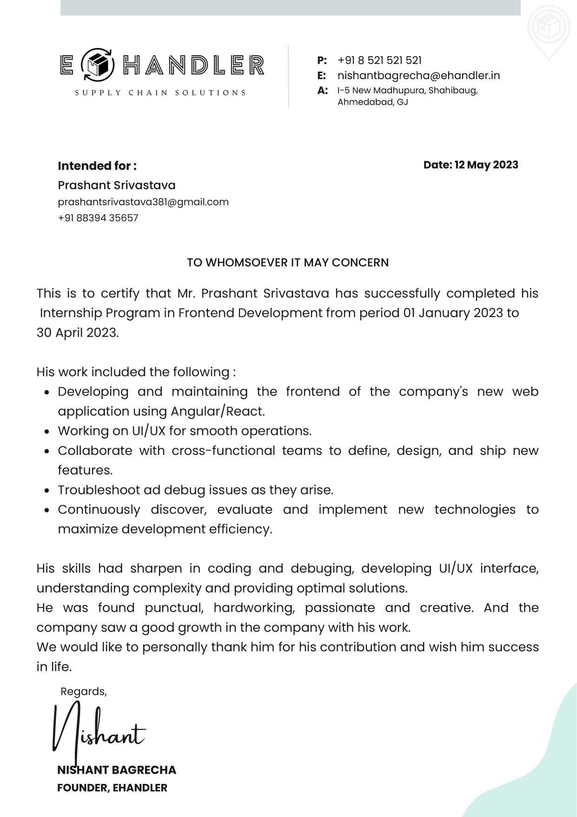

**TABLE OF CONTENTS**

**Declaration i**

**Acknowledgement ii**

**Certificate iii**

**Table of Contents v**

**Preface**

**Introduction 7**

**1. Title of Internship 7**

**2. Description of the Industry 8**

**3 Technologies Used**

**3.1 ReactJs 11**

**3.2 NodeJs 14**

**3.3 MongoDb 18**

**3.4 Express 21**

**4. Objective of the work 32**

**4. Work Done till now 36**

**5. Conclusion 42**

**References 43**

**LIST OF FIGURES**

***Number*****Page**

1. Login Page 38
2. User Dashboard Menu 38
3. Loader 39
4. ehandler.in home page 39
5. Ehandler website 40
6. Ehandler Booking menu 40
7. Ehandler Home route 41
8. Ehandler Dashboard menu 41

### LIST OF ABBREVEATIONS

1. JSX – Message Queuing Telemetry Transport
2. NPM – Node Package Manager
3. DOM – Document Object Model
4. UI – User Interface
5. API - Application Program Interface
6. JSON - JavaScript Object Notation
7. HTML - Hypertext Markup Language

Frontend Developer – Intern at eHandler

Frontend development, also known as client-side development, is the process of creating the user interface (UI) of a website or application. It involves writing code in languages such as HTML, CSS, and JavaScript to design and implement the visual and interactive elements that users see and interact with on a website or application. Frontend developers ensure that web pages and applications are visually appealing, easy to use, and accessible to users on a variety of devices and platforms. They work closely with designers, user experience (UX) specialists, and backend developers to ensure that the UI and functionality of a website or application work seamlessly together.



**Description of the Industry**



**eHandler provides the best Ecommerce Delivery & Ecommerce Order Fulfillment Services in India**

at eHandler, make sure the customer's requirement is fulfilled with passion and innovation -that's the path to sustain and achieve both market and technological leadership.

We are a group of young and enthusiastic doers who believes in creating innovation and delivering promises with your desired work. We are a small & confined group of people who studied Masters in Science in Germany and now our motto is to help contribute in the revolutionizing SCM Industry. We think always one step ahead.

We are actively promoting and trying to shape the technological transformation in ways that are future-oriented and responsible. Our products and services are adapted differently based on company's profile and your requirements, and they are among the best and Yes, based & inspired from German Technology.

**Tech Tools**

**Frontend – ReactJs**



For frontend design we have decided to use a ReactJs because ReactJS is an open-source JavaScript library for building user interfaces, primarily for web applications. It was developed by Facebook and is widely used in the industry due to its efficiency, flexibility, and component-based architecture. Here are some key points about ReactJS:

1. Component-based architecture: ReactJS is based on a component-based architecture, which allows developers to build reusable UI components. Components encapsulate their own logic, styles, and markup, making it easier to maintain and reuse code.

2. Virtual DOM: ReactJS introduces a virtual DOM (Document Object Model), which is an in-memory representation of the actual DOM. React uses the virtual DOM to efficiently update and render only the necessary components, reducing the performance overhead associated with frequent DOM manipulation.

3. JSX: ReactJS uses JSX (JavaScript XML), an extension to JavaScript that allows developers to write HTML-like code directly in their JavaScript files. JSX makes it easier to create and manipulate components by providing a declarative syntax.

4. Unidirectional data flow: React follows a unidirectional data flow pattern, known as Flux or Redux architecture. Data flows in a single direction, from parent components to child components, ensuring predictable and manageable state management.

5. Component lifecycle methods: React components have a set of lifecycle methods that are called at specific stages of a component's life, such as when it is mounted, updated, or unmounted. These lifecycle methods allow developers to perform tasks like initializing state, making API requests, and cleaning up resources.

6. React Router: React Router is a popular routing library for React applications. It enables developers to handle navigation and routing within a single-page application, allowing users to navigate between different views or pages without a full page reload.

7. React Hooks: Introduced in React version 16.8, React Hooks are functions that allow developers to add state and other React features to functional components. Hooks provide a simpler and more concise way to manage state and lifecycle in functional components, reducing the need for class components.

8. Community and ecosystem: ReactJS has a vast and active community, with numerous libraries, tools, and resources available for developers. This ecosystem provides solutions for state management (e.g., Redux, MobX), styling (e.g., Styled Components, CSS Modules), form handling (e.g., Formik, React Hook Form), and much more.

ReactJS has gained popularity for its ability to build dynamic and interactive user interfaces efficiently. It is widely used in modern web development and has a strong presence in the industry, making it a valuable skill for web developers.

**Backend – NodeJS**

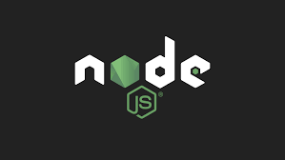

For backend we have decided to use NodeJs because Node.js is a powerful JavaScript runtime environment that allows you to run JavaScript code outside of a browser, making it well-suited for server-side or backend development. Here's some information about Node.js and its usage for backend development:

1. Asynchronous and event-driven: One of the key features of Node.js is its asynchronous, non-blocking I/O model. This means that Node.js can handle concurrent requests efficiently without blocking the execution of other operations. This makes it particularly suitable for handling high-traffic applications that require scalability and responsiveness.

2. Single-threaded and event loop: Node.js operates on a single-threaded event loop, which means it can handle many concurrent connections without the need for creating separate threads for each request. This event-driven architecture allows Node.js to handle multiple requests in a highly efficient manner.

3. NPM (Node Package Manager): Node.js comes with a package manager called NPM, which is a vast repository of open-source libraries and modules. NPM makes it easy to install, manage, and share reusable code, enabling developers to leverage existing solutions and accelerate development.

4. Large ecosystem: Node.js has a thriving ecosystem with a wide range of modules and frameworks that simplify backend development. Express.js, for example, is a popular web framework built on top of Node.js, providing a simple and flexible way to build web applications. Other frameworks like Koa.js, Hapi.js, and Nest.js offer additional features and abstractions for building scalable backend systems.

5. JSON-based APIs: Node.js is commonly used for building RESTful or GraphQL APIs. With its ability to handle I/O efficiently and process JSON data, Node.js is well-suited for handling requests, interacting with databases, and performing other backend operations in API development.

6. Database connectivity: Node.js has libraries and modules that provide easy integration with various databases, both SQL and NoSQL. Libraries like Sequelize, Knex.js, and Mongoose simplify database interactions and provide object-relational mapping (ORM) capabilities.

7. Microservices and serverless architecture: Node.js is often used in the context of microservices and serverless architectures. Its lightweight and scalable nature make it suitable for building modular, decoupled services that can be independently deployed and managed. Platforms like AWS Lambda and Google Cloud Functions support Node.js for serverless function deployments.

8. Real-time applications: Node.js, along with the WebSocket protocol and libraries like Socket.IO, is frequently used to build real-time applications such as chat applications, collaborative tools, and live data streaming systems. The event-driven nature of Node.js allows for efficient bidirectional communication between clients and servers.

Node.js has gained significant popularity in recent years due to its performance, scalability, and the ability to use JavaScript for both frontend and backend development, allowing developers to work seamlessly across the stack. It has a vast community and extensive resources, making it an excellent choice for backend development in JavaScript-based projects.

**Database – MongoDB**



MongoDB is a popular open-source NoSQL database management system that provides a flexible and scalable solution for storing, querying, and managing large volumes of structured and unstructured data. Here's an overview of MongoDB and its key features:

1. Document-oriented database: MongoDB is a document-oriented database, which means it stores data in flexible, JSON-like documents called BSON (Binary JSON). BSON documents can have varying structures and nested fields, allowing for easy representation of complex data models.

2. NoSQL and schema-less: Unlike traditional SQL databases, MongoDB is a NoSQL database that does not require a predefined schema. This flexibility allows for easy adaptation to evolving data models and faster development cycles. You can add, modify, or remove fields from documents without needing to modify the entire schema.

3. Scalability and performance: MongoDB is designed to scale horizontally, allowing you to distribute data across multiple servers or clusters to handle high traffic and large datasets. It supports automatic sharding, which partitions data across multiple machines, enabling horizontal scalability. Additionally, MongoDB's native support for caching and indexing provides fast and efficient data retrieval.

4. Rich query language: MongoDB provides a powerful query language that supports a wide range of operations for querying and manipulating data. Queries can use a flexible document-based query syntax and support advanced features like filtering, sorting, aggregation, and geospatial queries.

5. High availability and fault tolerance: MongoDB offers high availability through replica sets. A replica set consists of multiple copies (replicas) of the data, where one replica serves as the primary and others act as secondary replicas. If the primary replica fails, a secondary replica automatically takes over, ensuring continuous availability of the data.

6. Ad hoc queries and indexing: MongoDB allows you to perform ad hoc queries on any field, without the need for predefined indexes. However, you can create indexes to improve query performance for frequently accessed fields or complex queries.

7. Rich ecosystem and integration: MongoDB has a vast ecosystem with a wide range of drivers and libraries available for various programming languages, making it easy to integrate MongoDB into different applications and frameworks. Additionally, MongoDB provides official libraries, tools, and connectors for popular languages like JavaScript, Python, Java, and Node.js.

8. Aggregation framework: MongoDB's powerful aggregation framework enables complex data processing and analysis. It allows you to perform operations like grouping, filtering, sorting, and aggregating data, providing functionality similar to SQL's GROUP BY and JOIN operations.

9. Geospatial and full-text search: MongoDB supports geospatial queries, allowing you to perform location-based searches and calculations. It also provides full-text search capabilities, enabling efficient searching and indexing of text content within documents.

MongoDB is widely used in various applications, ranging from small-scale projects to large-scale enterprise applications. Its flexibility, scalability, and rich feature set make it a popular choice for developers working with large and evolving datasets, as well as those building modern web and mobile applications.

**Express JS**



Express.js is a popular web application framework for Node.js. It provides a minimalistic and flexible approach to building web applications and APIs. Here's some information about Express.js:

1. Minimalistic and unopinionated: Express.js is known for its minimalistic design and unopinionated nature. It provides a set of essential features for web development without imposing any specific architecture or design patterns. This flexibility allows developers to structure their applications according to their preferences and requirements.

2. Routing: Express.js offers a powerful routing system that enables developers to define routes for different HTTP methods (GET, POST, PUT, DELETE, etc.) and associate them with specific request handlers. This makes it easy to handle different API endpoints and define the behavior for each route.

3. Middleware: Middleware functions play a central role in Express.js. Middleware functions can be used to intercept and modify incoming requests or outgoing responses. They can perform tasks like request parsing, authentication, logging, error handling, and more. Express.js allows you to create custom middleware or use third-party middleware modules.

4. Request and response handling: Express.js simplifies handling of requests and responses. It provides a straightforward API for accessing request parameters, headers, and body data. It also offers methods to set response status codes, headers, and send response data in various formats (JSON, HTML, etc.).

5. Template engines: Express.js supports a wide range of template engines, such as EJS, Pug (formerly Jade), Handlebars, and more. Template engines facilitate server-side rendering and dynamic content generation. Express.js seamlessly integrates with these template engines, making it easier to generate HTML or other markup for the views.

6. Static file serving: Express.js allows serving static files (e.g., HTML, CSS, images) using its built-in middleware. This feature simplifies serving static assets like CSS and JavaScript files, making it easier to create static websites or serve client-side files in a web application.

7. Integration with databases: Express.js can be easily integrated with different databases, both SQL and NoSQL. It provides support for various database libraries and ORM (Object-Relational Mapping) tools, such as Sequelize, Mongoose, and Knex.js. This enables developers to interact with databases and perform CRUD (Create, Read, Update, Delete) operations efficiently.

8. Middleware ecosystem: Express.js has a vibrant ecosystem of middleware modules that extend its functionality. These middleware modules provide additional features like session management, authentication, validation, API documentation generation, rate limiting, and more. Developers can leverage these modules to enhance their Express.js applications quickly.

9. Scalability: Express.js is designed to be lightweight and scalable. It can handle a large number of concurrent connections efficiently, making it suitable for building scalable and high-performance web applications.

10. Community and resources: Express.js has a large and active community of developers. It offers extensive documentation, tutorials, and examples that help developers get started and learn best practices. The community also contributes a wide range of third-party packages and tools that extend the capabilities of Express.js.

Express.js is widely used for building web applications and APIs due to its simplicity, flexibility, and robustness. It has become the de facto choice for many Node.js developers and is well-suited for creating RESTful APIs, single-page applications, and server-side rendering applications.

**JavaScript**

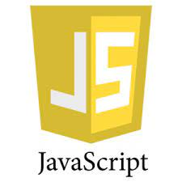

JavaScript is a popular programming language primarily used for front-end web development. It is a versatile language that can also be used for server-side development, scripting, and building mobile and desktop applications. Here are some key points about JavaScript:

1. Client-side web development: JavaScript is primarily known for its usage in client-side web development. It allows developers to create interactive and dynamic web pages by manipulating the Document Object Model (DOM), handling user events, and making asynchronous requests to fetch data from servers.

2. Cross-platform compatibility: JavaScript runs on virtually all web browsers, making it a universal language for client-side scripting. This enables developers to build web applications that can run on different devices and platforms without requiring platform-specific adaptations.

3. Modern JavaScript frameworks and libraries: JavaScript has a rich ecosystem of frameworks and libraries that simplify web development. Some popular front-end frameworks include React.js, Angular, and Vue.js. These frameworks provide reusable components, state management, and tools for building scalable and interactive web applications.

4. Server-side development: With the introduction of Node.js, JavaScript can now be used for server-side development as well. Node.js allows developers to build scalable and high-performance server applications using JavaScript. It leverages event-driven, non-blocking I/O to handle concurrent connections efficiently.

5. Asynchronous programming: JavaScript supports asynchronous programming through features like callbacks, Promises, and async/await. Asynchronous programming allows developers to perform non-blocking operations, such as making HTTP requests or querying databases, without blocking the execution of other code.

6. Object-oriented programming: JavaScript is a versatile language that supports both procedural and object-oriented programming paradigms. It provides objects, classes, and prototypes, allowing developers to create reusable and modular code.

7. Functional programming: JavaScript also supports functional programming concepts, such as higher-order functions, pure functions, and immutable data. Functional programming techniques can help in writing clean, concise, and maintainable code.

8. Integration with HTML and CSS: JavaScript integrates seamlessly with HTML and CSS, allowing developers to manipulate the structure, style, and behavior of web pages dynamically. It can be used to create animations, handle form validations, perform data calculations, and more.

9. JSON (JavaScript Object Notation): JavaScript is closely associated with JSON, a lightweight data interchange format. JSON is widely used for data storage and exchange, and JavaScript provides native support for parsing and generating JSON data.

10. Continuous growth and community support: JavaScript has experienced significant growth in recent years. It has a large and active community of developers who contribute to open-source projects, share resources, and provide support. The JavaScript ecosystem continues to evolve with new libraries, frameworks, and tools being developed regularly.

JavaScript is a powerful and versatile language that has become a fundamental technology for web development. Its ability to run on different platforms, combined with its extensive ecosystem and community support, makes it a valuable skill for developers across various domains.

These Software requirements are only for run this Project –

• Any web browser with HTML5.

• Operating system (Windows, Linux, Mac).

**IDE USED**



Visual Studio Code (VS Code) is a popular source code editor developed by Microsoft. It is highly regarded in the developer community for its extensive features, customizability, and wide range of language support. Here's some information about Visual Studio Code:

1. Cross-platform compatibility: VS Code is available for Windows, macOS, and Linux, making it a versatile choice for developers across different operating systems.

2. Lightweight and fast: Despite being feature-rich, VS Code is known for its fast startup time and overall performance. It is designed to be a lightweight editor that consumes minimal system resources.

3. IntelliSense: VS Code offers intelligent code completion, also known as IntelliSense, which provides context-aware suggestions and auto-completion while writing code. This feature saves developers time and helps reduce syntax errors.

4. Integrated terminal: VS Code has an integrated terminal that allows developers to run command-line tools and scripts without switching to an external terminal. The terminal is fully customizable and supports multiple shells, making it convenient for running build tasks and executing commands.

5. Extensions and Marketplace: VS Code has a rich extension ecosystem, offering a wide range of plugins and extensions for various programming languages, frameworks, and development tools. These extensions enhance functionality, provide language-specific features, and integrate with popular development tools and services. The VS Code Marketplace provides a centralized hub for discovering and installing extensions.

6. Version control integration: VS Code seamlessly integrates with popular version control systems like Git. It provides features such as source control management, diff views, and Git blame annotations, enabling developers to work with version-controlled projects efficiently.

7. Debugging support: VS Code offers built-in debugging capabilities for a variety of programming languages. It provides a user-friendly interface to set breakpoints, inspect variables, and step through code during the debugging process. Debugging can be done locally or remotely.

8. Customizability: VS Code can be customized extensively to suit individual preferences and workflows. Users can customize key bindings, themes, editor layouts, and install various productivity-enhancing extensions to tailor the editor to their specific needs.

9. Integrated task runner: VS Code includes a task runner that allows developers to automate common development tasks, such as running build scripts, compiling code, or executing tests. This integrated task system improves productivity by reducing manual repetitive tasks.

10. Collaboration and Live Share: VS Code provides Live Share, a feature that enables real-time collaboration between multiple developers. It allows them to share their editor sessions, code, and terminal with others, facilitating pair programming or collaborative debugging.

VS Code has gained significant popularity among developers due to its user-friendly interface, powerful features, and extensive customization options. It is widely used for a variety of programming languages and frameworks, making it a versatile and preferred choice for many developers and development teams.

**Objective of the work**

As a Frontend Developer in the logistics business, my main objective was be to create user-friendly and efficient web applications that improve the overall user experience of the logistics company's customers and employees. My work would help streamline the logistics process and make it more transparent and accessible.

Some specific objectives of my work include:

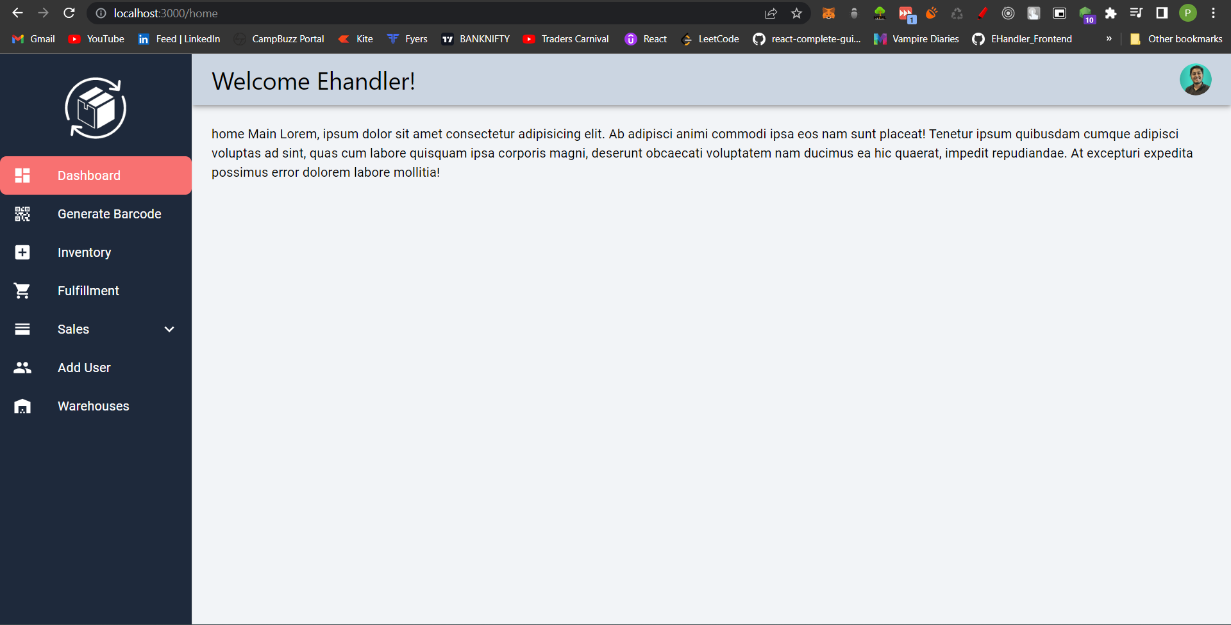

1. Developing intuitive and responsive web pages that allow customers to track shipments, view invoices, and manage their accounts easily.



2. Creating user-friendly dashboards and interfaces that give logistics employees quick access to real-time data, such as inventory levels, delivery statuses, and transportation routes.

3. Ensuring that the website and web applications are optimized for search engines, load quickly, and work seamlessly across different devices and browsers.



4. Collaborating with the design team to ensure that the website and web applications have a cohesive look and feel that aligns with the company's brand and values.

5. Implementing effective security measures to protect the company's data and customer information.

6. Keeping up-to-date with the latest technologies and trends in frontend development to continuously improve the company's web presence and user experience

**Work Done till now**

1. Working on their user dashboard

2. Made Full website **ehandler.in** and hosted on GoDaddy

3. Technology used Nextjs, **Reactjs**, Tailwind CSS,

HTML, CSS

4.Worked on their side project with api integration used axios

5. Made **Responsive design** (Mobile Friendly)

6. Developing and maintaining the frontend of the company's new web application using **React**.

7. Working on **UI/UX** for smooth operations.

8. Collaborate with cross-functional teams to define, design, and ship new features. Troubleshoot ad debug issues as they arise.

9. Continuously discover, evaluate and implement new technologies to maximize development efficiency

**Some Images of my work**

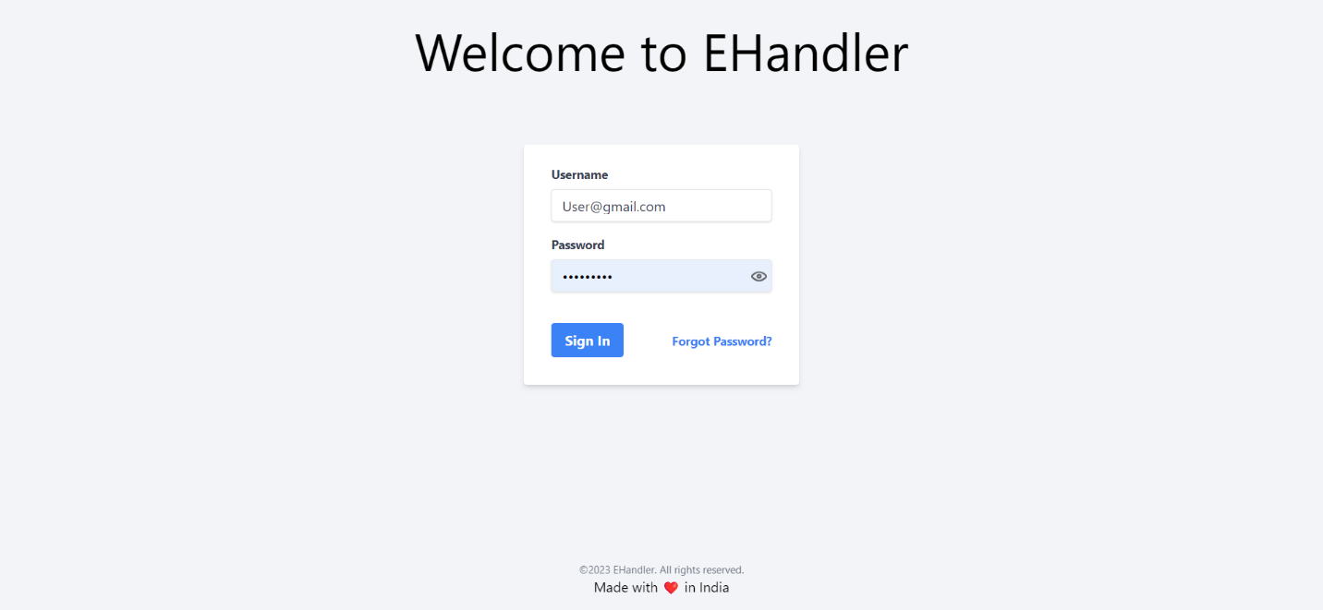



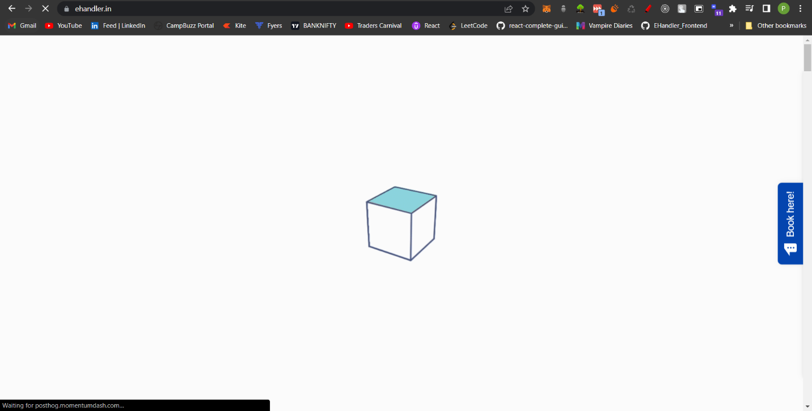



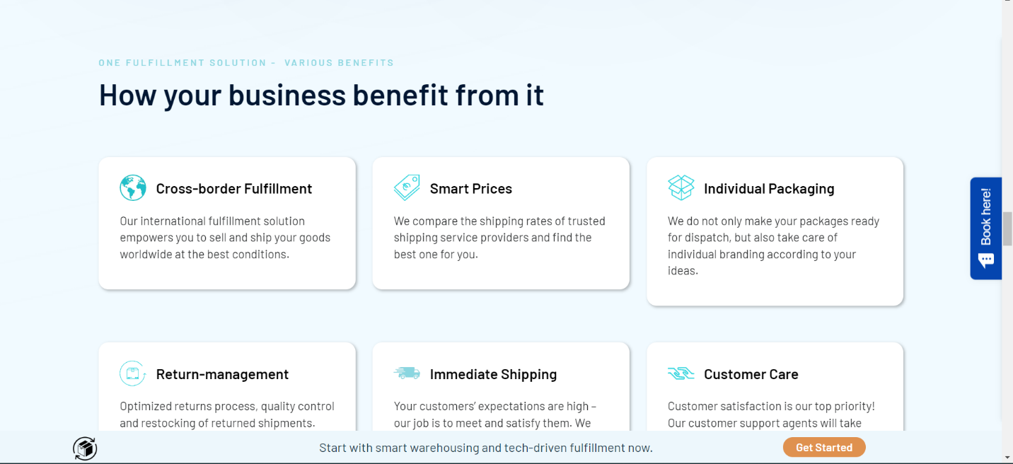

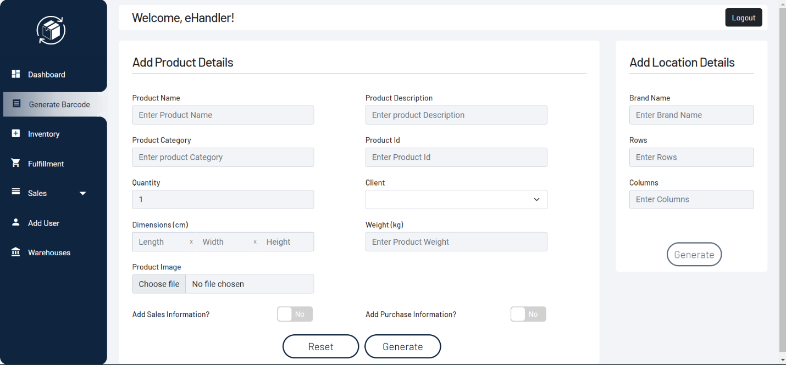

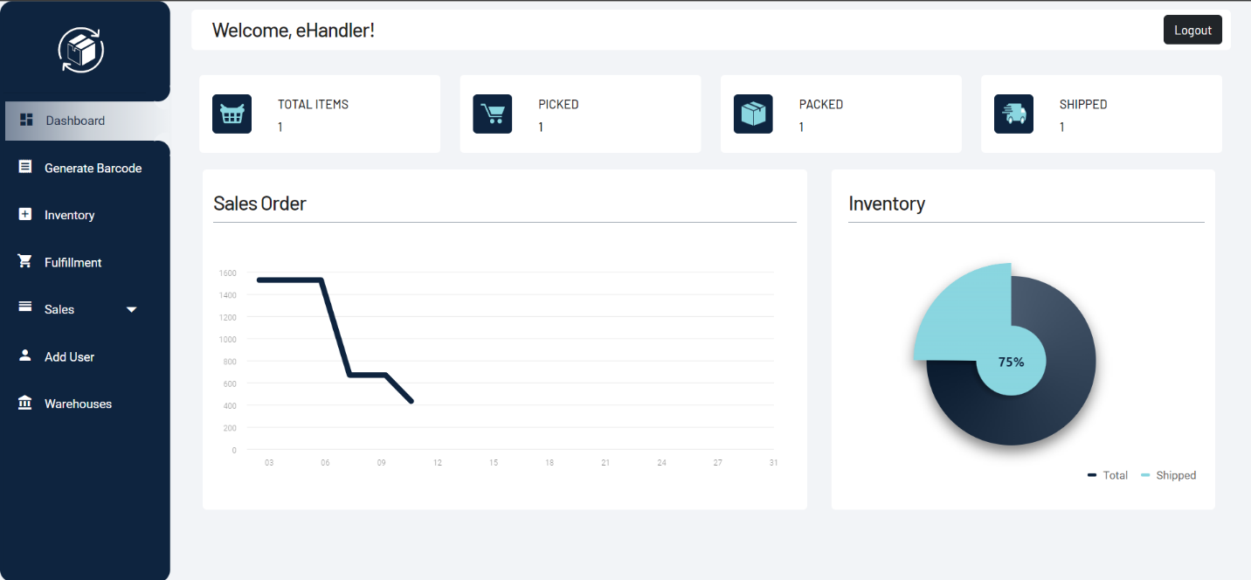

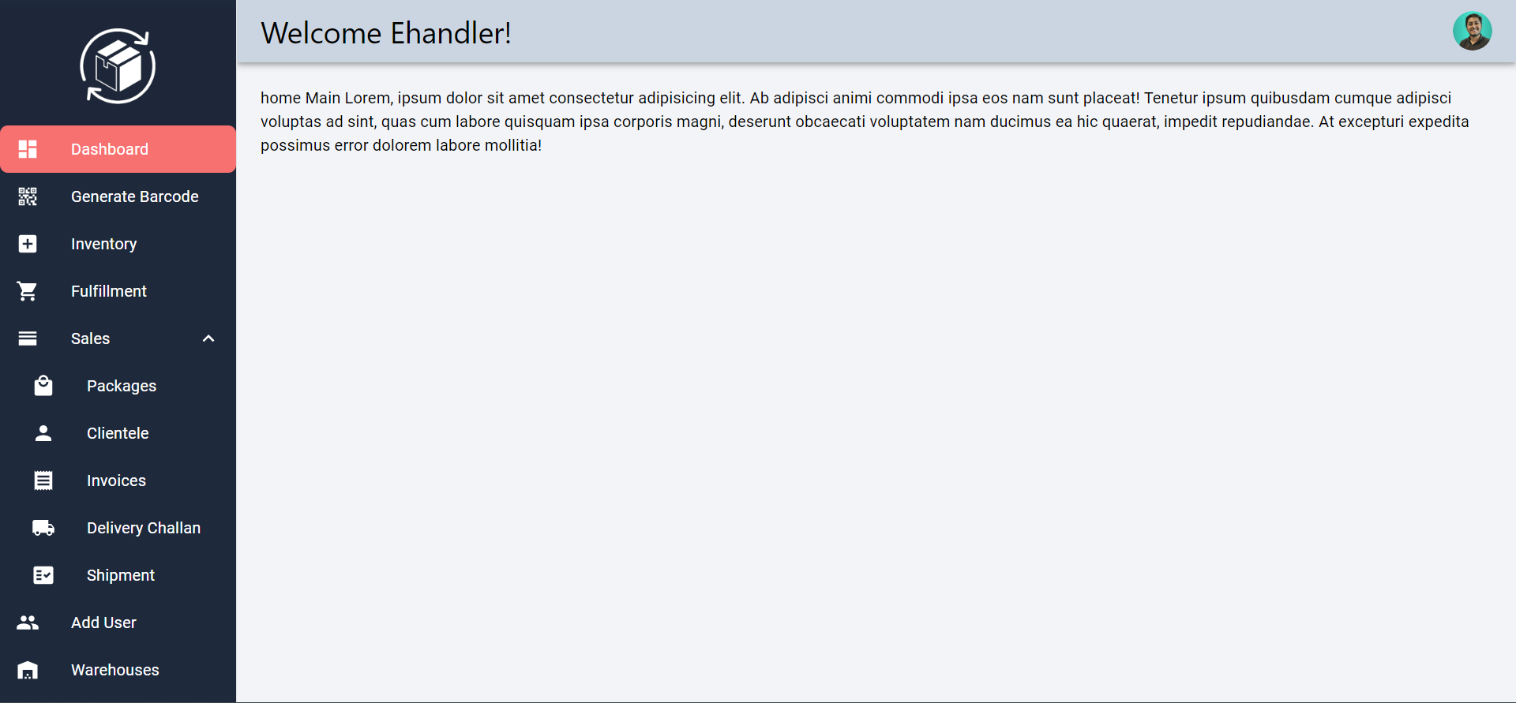

CONCLUSION

During my internship at eHandler, I had the privilege of working with a range of technologies including React, NextJs, HTML, CSS & JavaScript. These Technology are widely used in organizations and in making real world projects and I gained valuable hands-on experience with eHandler other side projects and Various API Integration.

At eHandler working as a frontend developer for 4 months I gained many new skills and much more experience, started with making dashboard till main website then hosting learned many things ,got to know how to work in team manage all the challenges and solving them .

Got much more good at ReactJs which is more in industry demand and sure will help me in future by taking many jobs.

**References**

https://www.geeksforgeeks.org/

https://www.w3schools.com/

https://developer.mozilla.org/en-US/

**Appendix B: Self Evaluation of Fortnightly Progress of Internship**

### Table: Contents of Fortnightly Progress of Internship

|  |  |
| --- | --- |
| **Weekly Report** | **Fortnightly Progress of Internship** |
| Week-1 | Code Familiarization with coding standards and best practices |
| Week-2 | Environment setup & Learning company's tech stack |
| Week-3 | Started working on Frontend Part of the Project.  Learning NextJs and Made Drawer Component |
| Week-4 | Introduced Navigation Toggle functionality |
| Week-5 | API Integration from backend and fetching their old code base from a domain for next task |
| Week-6 | Redesigning Ehandler Main Website Completely |
| Week-7 | Integrating Type Form in ehandler website Worked on Mobile Responsiveness for better user experience. |
| Week-8 | Code Restructuring for reusable code, changed repeating code to functions and did web hosting on GoDaddy |